Week Four Report
Tic Tac Toe

159.356 Software Engineering Capstone Project 2013
Massey University

Group 2
Max Dietrich
Ryan Murphy
Sarsha Jones
Jesse Voight
Luke Christiansen
Jason Rurunanra

Table of Contents

1.0 Process......................................................................................................................3
1.1 Requirements..................................................................................................3
1.1.1 Scope....................................................................................................3
1.1.2 Outside of Scope..................................................................................3
1.1.3 Schedule...............................................................................................3
1.2 Project Infrastructure.......................................................................................4
1.3 Life Cycle Model and Project Plan...................................................................4
1.3.1 Life Cycle Model...................................................................................4
1.3.2 Project Plan...........................................................................................5
1.3.3 Responsibilities.....................................................................................5
1.4 Technology Selection.......................................................................................6
1.5 Architecture.....................................................................................................6
1.6 Risk Management............................................................................................6
2.0 Quality Assurance......................................................................................................8
2.1 Testing.............................................................................................................8
2.2 Issue Tracking.................................................................................................8
3.0 Product.......................................................................................................................8
Appendix 1: Use Case Diagram........................................................................................11
1.1 Play a Game Use Case Diagram..................................................................11
1.2 Other Features Use Case Diagram...............................................................12
Appendix 2: Architecture Diagrams...................................................................................13
2.1 Player vs. Bot Activity Diagram......................................................................13
2.2 Player vs. Player Activity Diagram.................................................................14
2.3 Class Diagram...............................................................................................15

1.0 Process
1.1 Requirements

1.1.1 Scope
The requirements are for a browser (Safari, Chrome, and Firefox at a minimum) based game where users can play tic tac toe against bots or other players. Players will log into the web page using their email/screen name, Facebook account, or Google account. They will be able to create or join public games, as well as being able to create and join private games that can only been seen by their selected friends. Users will also be able to create their own bots which players can choose to play against. These user created bots can be public or private. Users will also be able to save played games and replay them.

Use case diagrams for playing a game and for using the other features of the product are included in Appendix 1.

1.1.2 Outside the Scope
Once opening a player vs. player game, any other appropriate (whether public player or play from the friends list) can join the game, the opening player has no ability to reject an appropriate player.

There will be no ability for players to communicate with each other in-game.

1.1.3 Schedule
The following schedule is based on the priority of the requirements.

Week 3: First Prototype
A working tic tac toe game with a functional user interface that runs in a browser with the game logic running on the server and a functional bot. The game will allow for player vs. bot games only.

Week 6: Second Prototype
The second prototype will allow for player vs. player games. The prototype will also be capable of allowing users to create and join private and public player vs. player games.

Week 9: Third Prototype
The third prototype will provide a mechanism for user accounts (including Facebook and Google accounts). It will also allow for players to create their own bots, both private and public, in Java and for the playback of past games.

Week 12: Final Game
The final game will provide for basic IDE functions in the bot creation section of the game. Bots will be verified to ensure they do not cause the game to hang or crash and it will be ensured that the player created bots do not compromise the security of the game or site.

1.2 Project Infrastructure
GitHub will be used as the project repository. All code will be stored there, along with documentation such as the project plan, the test plan, and diagrams. In addition, GitHub’s issue tracking system will be used for issue tracking and for the project management aspects. A Facebook group is used for communication between the team.

The process used to select this infrastructure was through a group discussion of the pros and cons of the available options. GitHub was chosen as the repository as it allowed the repository to be public and because it was the option the team members were most familiar with. None of the other options offered any relevant benefits over GitHub. To keep things simple and in one place, GitHub’s issue tracking system is used for issue tracking and project management. A Facebook group is used for communication as each team member uses Facebook, so it provides a convenient means of communicating with the entire team easily, where each team member will receive notifications of any new communications.

The final product will be built using NetBeans which does all the work of building the product. It will then be deployed to a remote server. Files will be uploaded to the server through FTP using a service such as FileZilla.

1.3 Life Cycle Model and Project Plan
1.3.1 Life Cycle Model
The project will follow an agile approach to development, in particular, feature driven development. This model was selected by the team based on the belief that the easiest way to manage the project would be to assign features to individual team members to implement, and then build up the project like that.

1.3.2 Project Plan
The project milestones are set out in section 1.1.3 Project Schedule above. This schedule is considered worst case. It is anticipated that features will be completed earlier than stated, in which case refinements can be undertaken and additional functionality can be added. The Project Plan can be found at: https://github.com/mbdietrich/MUCapstone2013_Team2/blob/master/CapstoneProject/docs/Project%20Plan.doc

1.3.3 Responsibilities
The responsibilities are as follows:
Max Dietrich:
Team leader
Server-side features

Ryan Murphy:
Bots
Testing

Sarsha Jones:
Code maintenance
Spikes

Jesse Voight:
Client-side features

Luke Christiansen:
Documentation

Jason Rurunanra:
User interface

While each team member is assigned the above responsibilities, other team members will assist as needed. There will also be regular team coding sessions where the team will work together to get features up and running, resolve issues, and fix bugs.

1.4 Technology Selection
At this stage we have selected the technologies to be used for the first prototype. This was predominantly decided based on the skills of the team. As such, Java has been selected to implement the game logic and server-side processing. HTML/CSS/JavaScript will be used to implement the client-side user interface. JSON will be used for the client/server interaction and JQuery used for the HTML scripting.

The technologies to be used for the features in future prototypes will be assessed at the time we plan each prototype.

1.5 Architecture
The game logic and state of each game will reside on the server. Communication with the client will be done through JSON. JQuery will be employed on the client-side to handle the HTML scripting.

Activity diagrams showing player vs. bot and player vs. player are included as Appendix 3. Diagrams for additional features will be completed when the implementation of those features is planned.

Also included in Appendix 3 is the Class Diagram for the first prototype.

1.6 Risk Management
The following risks have been identified:

- Miscommunication
Probability: Low
Prevention: Regular team meetings. A Facebook group allowing team members to communication with each other and the entire team. Comments and issue tracking in the repository.
Correction: If miscommunication is causing problems, a team member will record notes at the team meetings and post these to the Facebook group.
Impact: Medium

- Time shortage
Probability: Medium
Prevention: Care is taken to create a realistic development schedule. Regular meetings to discuss progress. If a team member is encountering problems, they will let the team know.
Correction: If tasks take more time than anticipated, the development schedule will be adjusted. If necessary, low priority features will be dropped.
Impact: High

- Design errors
Probability: Medium
Prevention: The design will be undertaken by the entire team as a group.
Correction: If a team member uncovers a design error, they note it on the Facebook group or the repository.
Impact: High

- Illness or other absence of team members
Probability: Low
Prevention: Team members will advise the team of any planned absence as soon as is practically possible.
Correction: Regular team meetings ensure that each team member knows what work the others are doing. Work completed by team members will be regularly pushed to the repository. If necessary, another team member will be assigned to take over the work of an absent team member.
Impact: Medium

- Workload from other papers impacting team members’ time
Probability: Medium
Prevention: Team members will manage their time to ensure they can complete their assigned task on time.
Correction: If a team member believes they will be unable to complete a task, they will advise the team so that the task can be reassigned as soon as possible.
Impact: Medium

- Inability to access repository
Probability: Low
Prevention: Team members will regularly pull the code from the repository so that there are backups on each team member’s computer.
Correction: If the repository can not be accessed, the team member who has most recently pulled the code from the repository will upload it to a new repository.
Impact: Low

2.0 Quality Assurance
2.1 Testing
Quality assurance will predominantly be achieved through testing. Regression tests will be written for all core functions, being: game rules/logic, client/server interaction, the game bot, and checking the validity of user-created bots. In addition to regression testing, browser compatibility and end user testing will also be undertaken.

Along with testing, the code completed by each team member will be peer reviewed by at least one other team member.

2.2 Issue Tracking
All team members will be responsible for issue tracking. Any issues identified will be entered into the repository’s issue tracking system and assigned to the team member responsible for that feature. All open issues will be discussed at the twice weekly team meetings.

3.0 Product
A class diagram for the first prototype is included as Appendix 3.3.

The prototype can be built and run using NetBeans. It then runs using the Tomcat server. The game can be accessed through a browser (Safari, Firefox, and Chrome have all been tested) using “the server’s IP address and port”/CapstoneProject/

The executables developed so far are as follows:

Web Site
Description:
The web site consists of a basic login screen where a player enters their name. This takes them to the “lobby” where they can choose to play a new game. This in turn takes the player to a page with a functional Tic Tac Toe board, allowing them to play a game against the default bot.
Files:
game.jsp, index.jsp, lobby.jsp, jquery-1.8.3.js, style.css

Server
Description:
The server handles the communication between the client and the game. It manages the creation of games, the joining of players, the making of moves, and the sending of the game state to the client. At this stage only player vs. bot games are supported.
Files:
GameCreate.java, GameManager.java, GameStateGet.java, JSONBuilder.java, MakeMove.java, PlayerJoin.java, RemotePlayer.java, SessionCleanupService.java

Player
Description:
The player files handle the storing of player and bot information. At this stage only a “dumb” bot exists that makes valid moves, but which makes no attempt at winning a game.
Files:
Bot.java, GameBot.java, Player.java.

Game
Description:
The game files store the state of games, the rules, and ensure that only valid moves can be made. At this stage subgames may still be played in provided the subgame has not been won and that there are still positions available to play; that is, subgames are not ended at the point at which a draw is inevitable.
Files:
Coordinates.java, GameRules.java, GameSession.java, GameState.java, IllegalGameException.java, SubGame.java.

Appendix 1: Use Case Diagrams
1.1 Play a Game Use Case Diagram
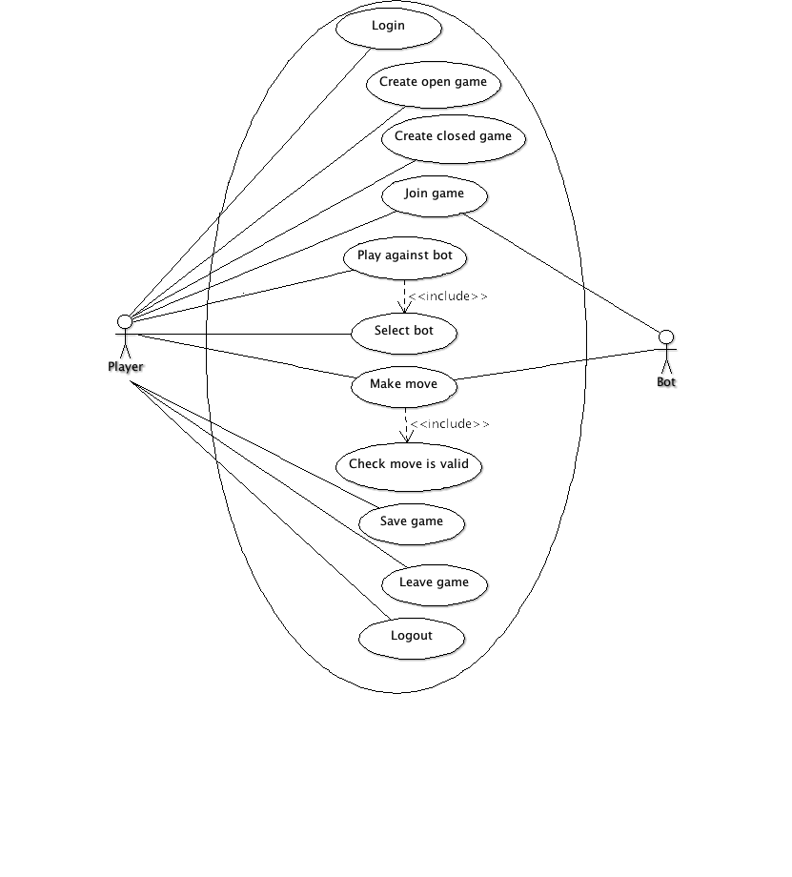

1.2 Other Features Use Case Diagram
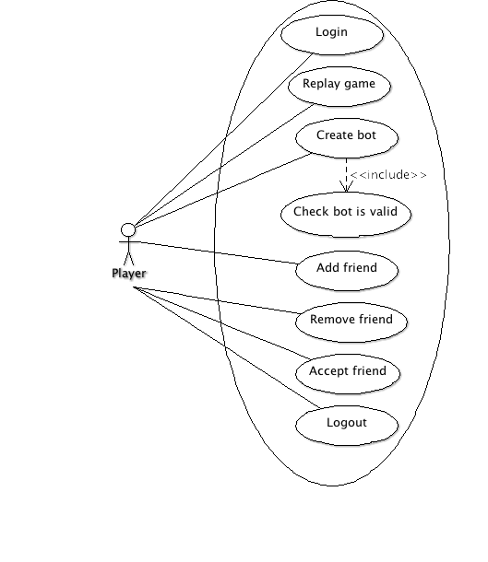

Appendix 2: Architecture Diagrams
2.1 Player vs. Bot Activity Diagram
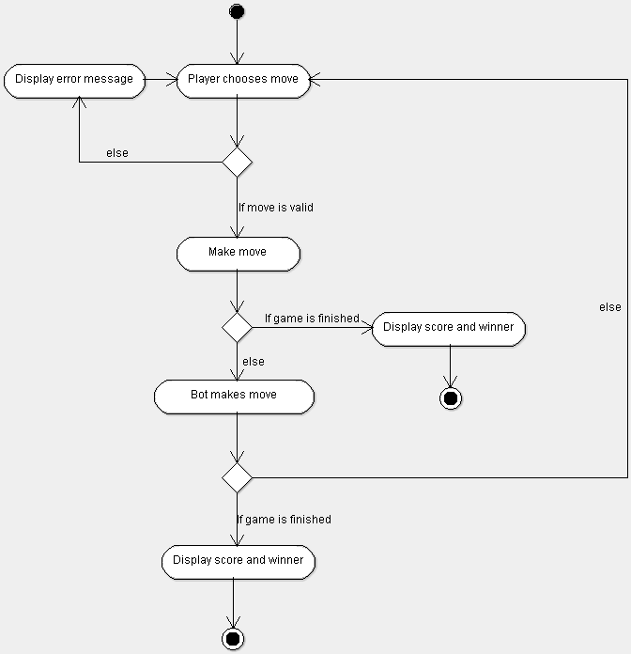

2.2 Player vs. Player Activity Diagram
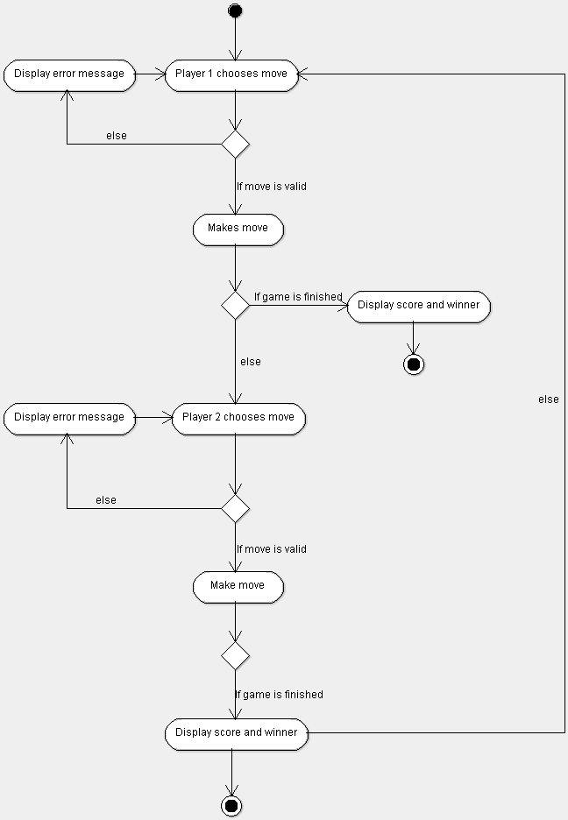

2.3 Class Diagram

